EXPT NO:2 | LOAD AND VISUALIZE A DATASET USING TABLEAU and PowerBI
DATE: 10.07.2026

PRE-LAB QUESTIONS

1. Why is Tableau a preferred tool for data visualization?
It offers an intuitive drag-and-drop interface, supports a wide range of chart types, connects to numerous data sources, and produces highly interactive, visually polished dashboards without needing extensive coding.

2. What is the primary use of a line chart in data analysis?
To show trends and changes in a metric over a continuous variable, typically time.

3. When would you use a tree map instead of a bar chart?
When comparing proportions across many hierarchical categories/sub-categories at once, especially when space is limited — tree maps show part-to-whole relationships more compactly than bar charts.

4. What is the significance of filters in Tableau visualizations?
Filters let users focus on specific subsets of data (e.g., a particular region or year), making analysis more targeted and dashboards more interactive.

5. How does Tableau handle geographic data for visualizations?
Tableau automatically recognizes geographic fields (like Country, State, City) and can plot them on a map using built-in geocoding, allowing size/color to represent measures like Sales.

IN-LAB EXERCISE:
OBJECTIVE:
To load a dataset into Tableau, create a variety of visualizations, and derive insights from the data using different chart types available in Tableau.
PROCEDURE:
Dataset Selection:
Use the Global Superstore Sales Dataset (available on Kaggle or Tableau's sample datasets).
Ensure the dataset includes fields like Order Date, Category, Region, Sales, Profit, and Customer Segment.
Data Loading:
Open Tableau and connect to the dataset.
Review the dataset structure, field data types, and missing values.
Chart Creations (Step-by-Step):
- Bar Chart:
Objective: Compare total sales by region and category.
Plot Region on the x-axis and Sales on the y-axis.
Add Category as a color dimension.
- Line Chart:
Objective: Visualize sales trends over time.
Place Order Date on the x-axis and Sales on the y-axis.
Set granularity to Month and color by Category.
- Pie Chart:
Objective: Show sales distribution by product category. Assign Category as the dimension and Sales as the measure.
- Scatter Plot:
Objective: Examine the relationship between profit and sales.
Plot Profit on the x-axis and Sales on the y-axis.
Use Sub-Category as the color dimension.
- Heatmap:
Objective: Compare sales across categories and regions.
Use Region and Category as dimensions. Use Sales as the measure and apply color coding.
- Geographical Map:
Objective: Visualize total sales by country.
Set Country as the geographical field. Use Sales to define size and color gradients.
- Tree Map:
Objective: Display sales distribution by category and sub-category.
Use Category and Sub-Category as dimensions, and Sales as the measure.
Customization and Interactivity:
Add filters to explore data subsets interactively (e.g., by year, region, or category).
Include annotations, labels, and formatting for clarity.
Dashboard Creation:
Combine all charts into a single dashboard to present a cohesive story.
Add interactive filters and tooltips for dynamic exploration.
Experiment Dataset:
Global Superstore Sales Dataset
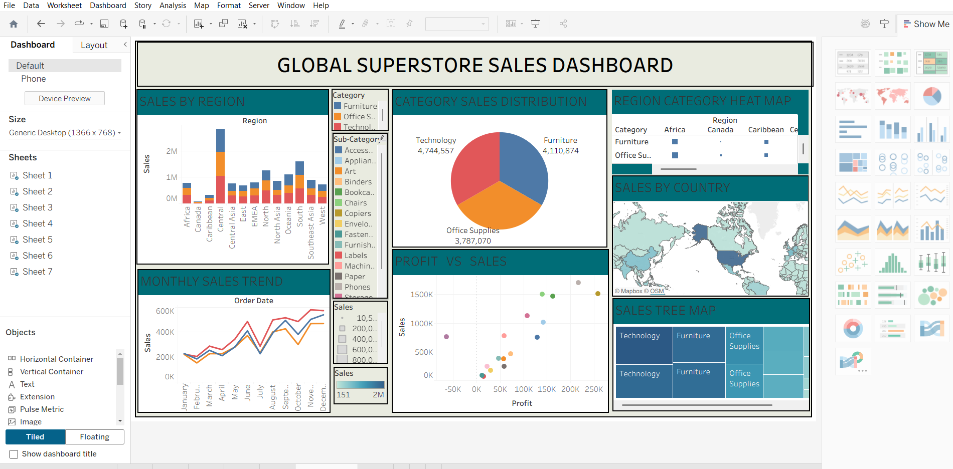

POST-LAB QUESTIONS
Bar Chart:
- Highest/lowest sales regions depend on your actual output — typically in the Superstore dataset, regions like the US West/East show higher sales, while smaller regions show lower sales.
- Category performance varies — e.g., Technology often outperforms Furniture in certain regions.
Line Chart:
- Peak sales month is usually toward year-end (November/December) due to holiday season trends.
- Categories like Technology often show more consistent growth compared to Furniture.
Pie Chart:
- Technology or Office Supplies typically contributes the most to overall sales.
- Categories with very few sub-categories (e.g., certain niche categories) show negligible contribution.
Scatter Plot:
- There is often a positive correlation between profit and sales, though some high-sales sub-categories show low or negative profit due to heavy discounting.
- Sub-categories like Tables or Bookcases often show high sales but low/negative profit.
Heatmap:
- The highest sales combination is often Technology in the West/East region.
- Regions with weaker performance across categories are typically smaller/central regions.
Geographical Map:
- The United States typically shows the highest total sales in the Superstore dataset.
- Smaller or less economically active countries/regions show minimal sales.
Tree Map:
- Dominant sub-categories are often Phones (Technology) or Chairs (Furniture).
- Sub-categories like Fasteners or Labels often show unexpectedly low sales.
Dashboard:
- Combining visuals reveals a fuller picture — e.g., which regions perform well in both sales and profit simultaneously.
- Filters let users isolate specific years, regions, or categories, turning a static report into a dynamic exploration tool.

ASSESSMENT

Description |  | Max Marks | Marks Awarded
Pre Lab Exercise |  | 5
In Lab Exercise |  | 10
Post Lab Exercise |  | 5
Viva |  | 10
 | Total | 30
 |  | Faculty Signature

